INTRODUCTION:

Overviwe:

An airplane crash analysis is a detailed investigation into the causes of an aviation accident. The goal of an airplane crash analysis is to identify any factors that contributed to the accident, with the ultimate goal of improving safety and preventing future accidents. The process of conducting an airplane crash analysis typically involves the collection and analysis of a wide range of data, including information about the aircraft and its systems, the operators, and any other relevant factors.

Purpose:

This data is typically collected from Kaggle. Once the data has been collected, it is analysed through tableau, to identify any potential causes of the accident. The results of an airplane crash analysis are typically published in a report, which may include recommendations for improving safety and preventing similar accidents in the future. These recommendations may be implemented by the relevant authorities or industry organizations.

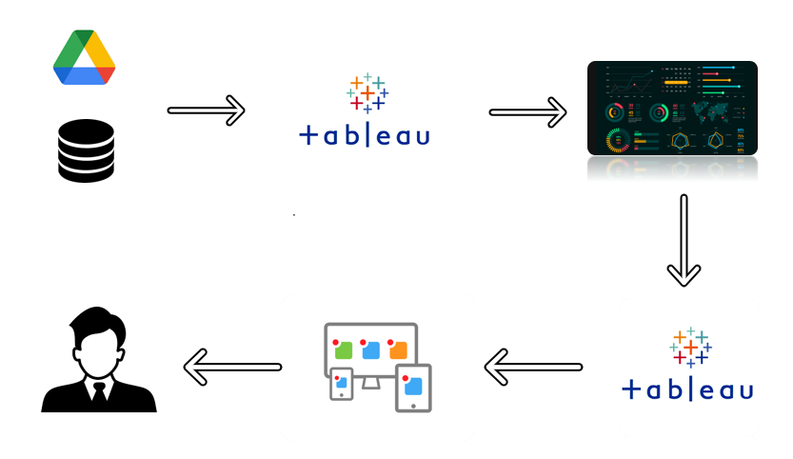

PROBLEM DEFINITION & DESIGN THINKING:

Ideation and brainstorming:



RESULT:

Screenshot:

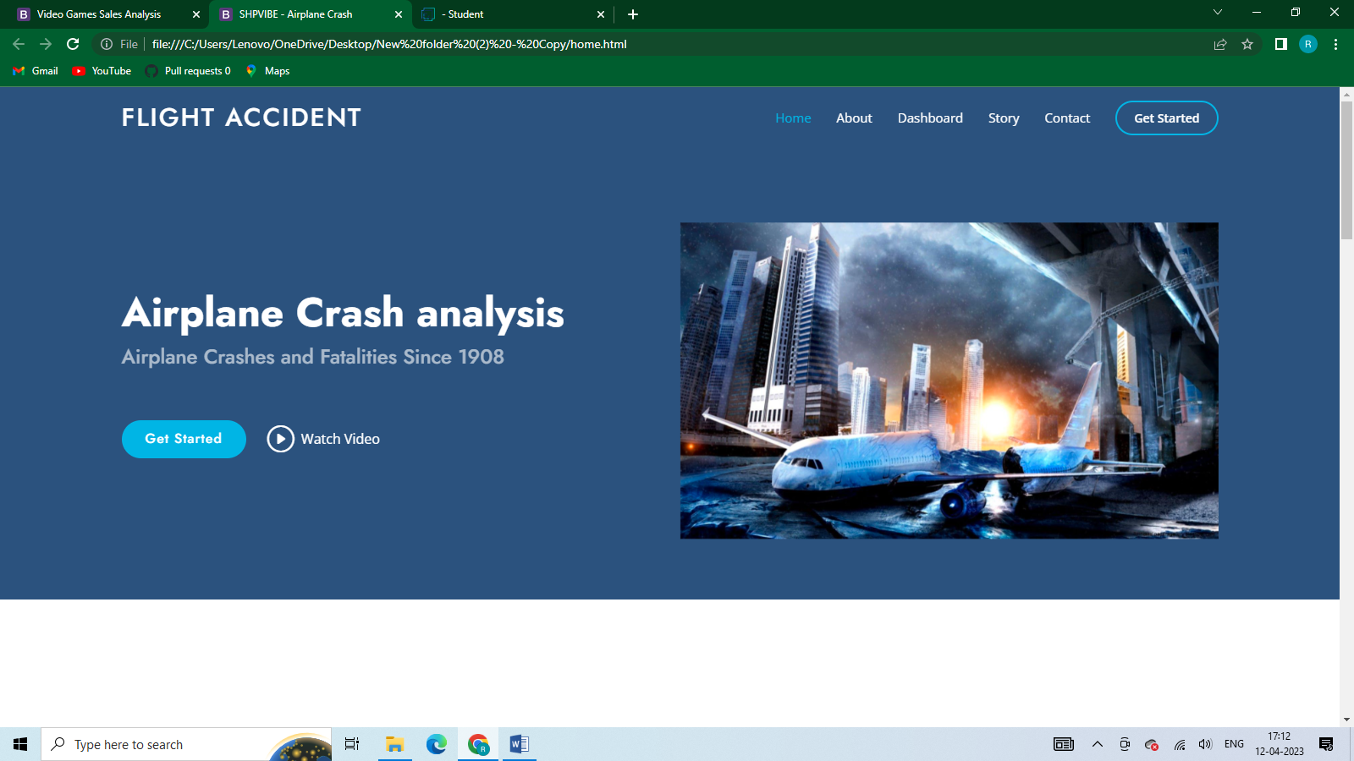

ADVANTAGES & DISADVANTAGES:

[Advantages Of Air Transport](https://abrokenbackpack.com/advantages-and-disadvantages-of-air-transport/#5_Advantages_Of_Air_Transport)

[1. It’s The Fastest Way To Travel Long Distances](https://abrokenbackpack.com/advantages-and-disadvantages-of-air-transport/#1_Its_The_Fastest_Way_To_Travel_Long_Distances)

[2. It’s The Most Efficient Way To Travel Long Distances](https://abrokenbackpack.com/advantages-and-disadvantages-of-air-transport/#2_Its_The_Most_Efficient_Way_To_Travel_Long_Distances)

[3. Planes Can Carry A Lot Of Weight](https://abrokenbackpack.com/advantages-and-disadvantages-of-air-transport/#3_Planes_Can_Carry_A_Lot_Of_Weight)

[4. You Can Fly Everywhere](https://abrokenbackpack.com/advantages-and-disadvantages-of-air-transport/#4_You_Can_Fly_Everywhere)

[5. It’s Safe](https://abrokenbackpack.com/advantages-and-disadvantages-of-air-transport/#5_Its_Safe)

[Disadvantages Of Air Transport](https://abrokenbackpack.com/advantages-and-disadvantages-of-air-transport/#6_Disadvantages_Of_Air_Transport)

[1. It Can Be Expensive Depending On The Route And Season](https://abrokenbackpack.com/advantages-and-disadvantages-of-air-transport/#1_It_Can_Be_Expensive_Depending_On_The_Route_And_Season)

[2. You Might Have To Fly Early Or Late](https://abrokenbackpack.com/advantages-and-disadvantages-of-air-transport/#2_You_Might_Have_To_Fly_Early_Or_Late)

[3. You Might Have To Fly In A Middle Seat](https://abrokenbackpack.com/advantages-and-disadvantages-of-air-transport/#3_You_Might_Have_To_Fly_In_A_Middle_Seat)

[4. Security Measures Can Be Inconvenient And Time-consuming](https://abrokenbackpack.com/advantages-and-disadvantages-of-air-transport/#4_Security_Measures_Can_Be_Inconvenient_And_Time-consuming)

[5. It Can Be Uncomfortable For Long Journeys](https://abrokenbackpack.com/advantages-and-disadvantages-of-air-transport/#5_It_Can_Be_Uncomfortable_For_Long_Journeys)

[6. The Journey Can Be Long If You Have Stopovers](https://abrokenbackpack.com/advantages-and-disadvantages-of-air-transport/#6_The_Journey_Can_Be_Long_If_You_Have_Stopovers)

[Final Thoughts On Traveling By Plane](https://abrokenbackpack.com/advantages-and-disadvantages-of-air-transport/#Final_Thoughts_On_Traveling_By_Plane)

APPLICATION:

When an official investigator reports the "probable causes" of an accident or incident, consideration should be given to all of the events and cause factors. Cause factors can be grouped into the following categories:

human factors/personnel error

malfunction or failure of aircraft structures, engines, or other systems

deficient maintenance

hazardous environment involving weather, volcanic ash, birds, etc.

air traffic management errors

any combination of the above

Identifying the precise cause factors for each event can be complicated, requiring good judgment and accurate interpretation of the facts. There could be more than one cause factor for each event, and some cause factors naturally overlap.

Human factors include mistakes caused by voluntary acts, failure to act, and other factors associated with actions or inaction.3

Cause factors associated with aircraft, engines, and systems include deficiencies in the design, manufacture, maintenance, or operation of the aircraft or its systems.

Maintenance-related cause factors include improperly performed maintenance and inadequate maintenance procedures and plans.

Environmental cause factors include hazardous weather, volcanic ash, sand, dust, and birds.

Cause factors associated with air traffic management include deficiencies in weather reporting, regulations, and the air traffic control system .

CONCLUTION:

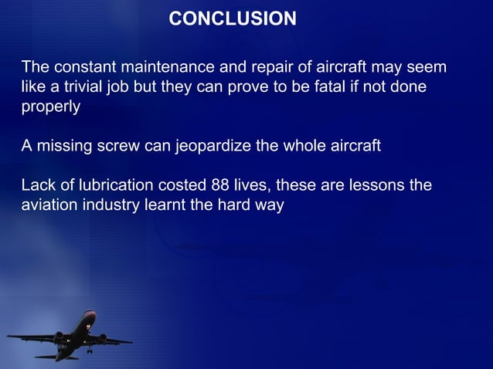

FUTRUE SCOPE:

• Transmission–Top mounted antennas communicate with satellites at higher altitudes, at lower altitudes, data can be sent directly to the ground receivers.

• Bandwidth – To save money, aircrafts could flash data intermittently, switching to streaming ways in an emergency.

• Satellites – By 2015, a constellation of dedicated search towards technology, rescue satellites will track aeroplanes exact location more quickly globally.

• Storage Servers – Today, uncountable servers around the world stores & send real time flights recorded data. Eventually, in coming future every airline would have its own server.

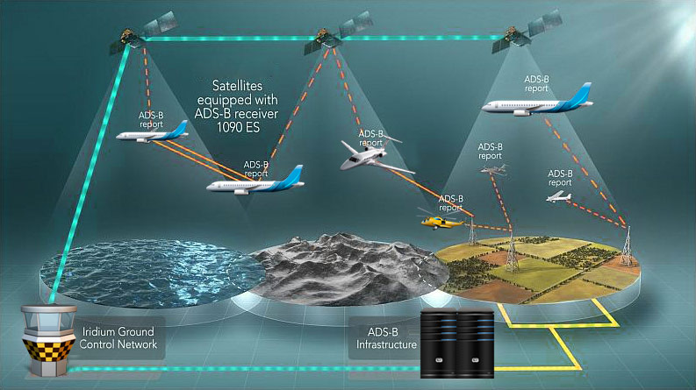

|  |  |
| --- | --- |
|  | APPENDEX: |
|  |  |
|  |  |
|  | <!doctype html> |
|  | <html lang="en"> |
|  | <head> |
|  | <meta charset="utf-8"> |
|  | <meta name="viewport" content="width=device-width, initial-scale=2"> |
|  | <title>gaming industries</title> |
|  | <link rel="stylesheet" href="style.css"> |
|  | <link href="<https://cdn.jsdelivr.net/npm/bootstrap@5.3.0-alpha3/dist/css/bootstrap.min.css>" rel="stylesheet" integrity="sha384-KK94CHFLLe+nY2dmCWGMq91rCGa5gtU4mk92HdvYe+M/SXH301p5ILy+dN9+nJOZ" crossorigin="anonymous"> |
|  | </head> |
|  | </head> |
|  | <body> |
|  |  |
|  |  |
|  |  |
|  |  |
|  | <nav class="navbar navbar-expand-lg bg-body-tertiary"> |
|  | <div class="container-fluid"> |
|  | <a class="navbar-brand" href="#">flight accident analysis by anand</a> |
|  | <button class="navbar-toggler" type="button" data-bs-toggle="collapse" data-bs-target="#navbarNavAltMarkup" aria-controls="navbarNavAltMarkup" aria-expanded="false" aria-label="Toggle navigation"> |
|  | <span class="navbar-toggler-icon"></span> |
|  | </button> |
|  | <div class="collapse navbar-collapse" id="navbarNavAltMarkup"> |
|  | <div class="navbar-nav"> |
|  | </div> |
|  | </div> |
|  | </div> |
|  | </nav> |
|  |  |
|  |  |
|  | <div class='tableauPlaceholder' id='viz1681107843909' style='position: relative'><noscript><a href='#'><img alt='Dashboard 3 ' src='https:&#47;&#47;public.tableau.com&#47;static&#47;images&#47;fl&#47;flightaccidentanalysis&#47;Dashboard3&#47;1_rss.png' style='border: none' /></a></noscript><object class='tableauViz' style='display:none;'><param name='host_url' value='https%3A%2F%2Fpublic.tableau.com%2F' /> <param name='embed_code_version' value='3' /> <param name='site_root' value='' /><param name='name' value='flightaccidentanalysis&#47;Dashboard3' /><param name='tabs' value='no' /><param name='toolbar' value='yes' /><param name='static_image' value='https:&#47;&#47;public.tableau.com&#47;static&#47;images&#47;fl&#47;flightaccidentanalysis&#47;Dashboard3&#47;1.png' /> <param name='animate_transition' value='yes' /><param name='display_static_image' value='yes' /><param name='display_spinner' value='yes' /><param name='display_overlay' value='yes' /><param name='display_count' value='yes' /><param name='language' value='en-GB' /></object></div> <script type='text/javascript'> var divElement = document.getElementById('viz1681107843909'); var vizElement = divElement.getElementsByTagName('object')[0]; if ( divElement.offsetWidth > 800 ) { vizElement.style.width='100%';vizElement.style.height=(divElement.offsetWidth*0.75)+'px';} else if ( divElement.offsetWidth > 500 ) { vizElement.style.width='100%';vizElement.style.height=(divElement.offsetWidth*0.75)+'px';} else { vizElement.style.width='100%';vizElement.style.height='727px';} var scriptElement = document.createElement('script'); scriptElement.src = 'https://public.tableau.com/javascripts/api/viz_v1.js'; vizElement.parentNode.insertBefore(scriptElement, vizElement); </script> |
|  |  |
|  |  |
|  |  |
|  |  |
|  |  |
|  |  |
|  |  |
|  | <script src="<https://cdn.jsdelivr.net/npm/bootstrap@5.3.0-alpha3/dist/js/bootstrap.bundle.min.js>" integrity="sha384-ENjdO4Dr2bkBIFxQpeoTz1HIcje39Wm4jDKdf19U8gI4ddQ3GYNS7NTKfAdVQSZe" crossorigin="anonymous"></script> |
|  |  |
|  |  |
|  |  |
|  |  |
|  | </body> |
|  | </html> |

APPENDIX:

Basic code for the html wed design:

|  |  |
| --- | --- |
|  |  |